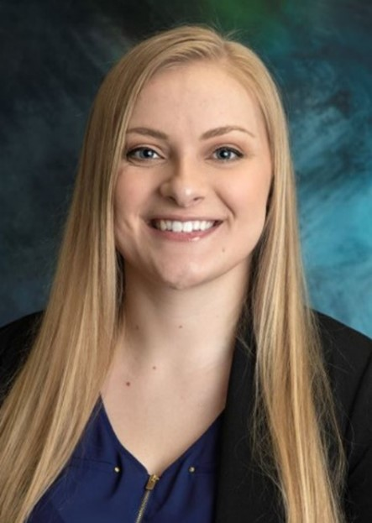
Coach Krystal Brodeen is currently the head women's basketball coach and athletic director at Central Lakes College in Brainerd, MN. She recently completed her fourth season at CLC and second year as the Raiders Athletic Director. For the fourth year in a row, the Raiders had three student-athletes named to the MCAC All-Division Team for the 2025-26 season, and made to the semifinals of the Region 13 Tournament. In her first year at CLC in 2022-23, the Raiders finished with a 14-7 record and were named the MCAC Northern Division Co-Champions for the first time since 1996-97. Coach Brodeen was also named the MCAC Northern Division Coach of the Year.
Krystal graduated from North Woods High School in its inaugural year of 2012, where she lettered in both volleyball and basketball for 4 years. She went on to play both volleyball and basketball during her time as a student at Vermilion Community College, earning All-Academic awards and graduating in 2015. After graduating from Vermilion, Krystal went on to graduate from Bemidji State University with her Bachelor's degree in Business Administration Management in 2016. She also graduated from Concordia University Irvine with her Master's degree in Coaching and Athletic Administration in 2021.
During the off-season, Coach Krystal also helps with youth basketball camps through Pacesetter Sports and CLC Athletics, and is an active member of the Women's Basketball Coaches Association. She is also currently the athletic director and teaches at Central Lakes College.

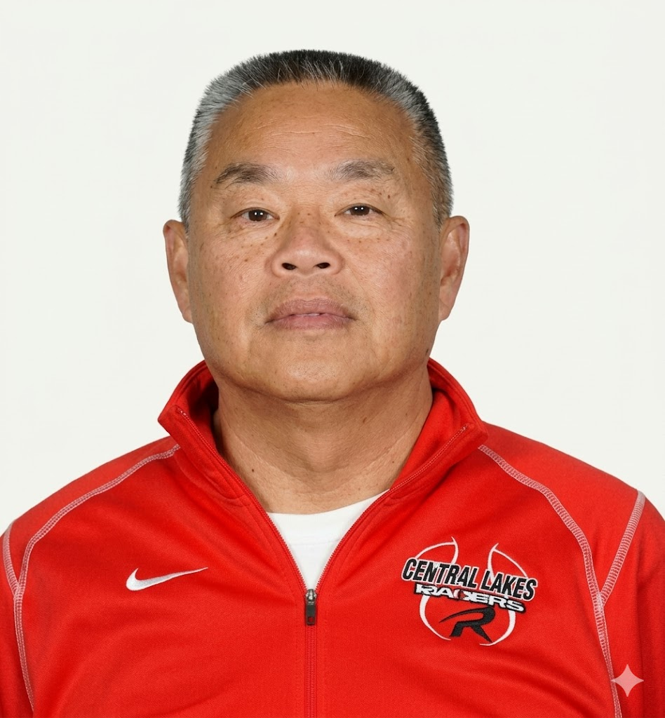
Jim Russell enters his 29th season as the head coach of the men’s basketball team at Central Lakes College, where he has built a legacy of success and achievement. With an impressive overall record of 557-234 and a conference record of 279-73, Coach Russell has guided his teams to ten conference titles, 26 state tournament appearances, and three NJCAA National Tournaments (2007-08, 2011-12, and 2018-19).
Coach Russell’s coaching excellence has earned him numerous accolades while at Central Lakes College, including Region XIII Coach of the Year honors in 2008, 2012, and 2019, as well as MCAC Coach of the Year in 1998, 2004, 2010, 2012, 2015, 2019, 2022, 2025 and 2026.
Beyond his on-court success, Coach Russell is deeply committed to the growth and development of his student-athletes. He emphasizes hard work, mastering the fundamentals, and personal development, ensuring his players excel both academically and athletically. Many of his players have gone on to continue their careers at NCAA DI, DII, DIII and NAIA institutions. In addition to his coaching career, Coach Russell was recently inducted into the Hall of Fame at Western Colorado University, further cementing his impact on the sport.

