Boys: Paul McDonald, retired head men’s coach at Vermilion C. C.

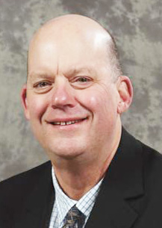
The name “McDonald” is synonymous with Minnesota basketball. Paul played four seasons for his father, Bob McDonald, at Chisholm High School, winning two state titles while helping the Bluestreaks to a four-year record of 98-8. Paul left Chisholm for the college game (Nebraska and So. Dakota State) before starting his coaching career at the high school level in Cotton and Tower-Soudan.

He recently retired after his 29th season as head coach at Vermilion Community College, where he’d captured state, region, and district Coach of the Year honors. Paul, who had more than 500 career wins at Vermilion, was a two-time finalist for the NJCCA National Coach of the Year award. He’s sent nine players to D1 basketball teams, has coached fifteen All-Americans, and has qualified for 23 straight State Tournaments, which is a record.

Paul is currently a St. Louis County Commissioner.

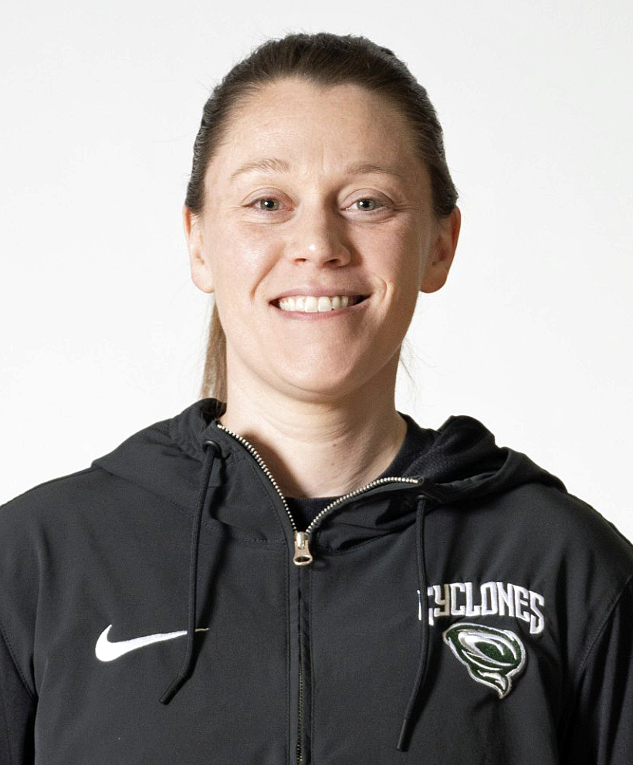
Girls: Abby Notch, current head women’s coach at St. Cloud Technical & C.C.
A 2013 graduate of St. Cloud Apollo High School, Abby went on to play three years of college basketball, gaining valuable experience that continues to shape her coaching philosophy.
Now in her fourth season as Head Coach at St. Cloud Technical & Community College, Abby brings nine years of overall coaching experience to the sideline. In the offseason, she also coaches with the Minnesota Suns AAU program, where she works with athletes to elevate their skills and prepare them for the next level.
Abby earned her Associate of Arts degree from the St. Cloud Technical & Community College before completing her Bachelor’s degree in Kinesiology at the University of North Dakota.

Grounded in her playing background and athletic training in kinesiology, Abby brings a well-rounded, development-focused approach to the game — committed to helping student-athletes grow as competitors, teammates, and leaders on and off the court.

